

**Lab Manual- Deploy to Cloud Run**

**Prepared for**:

**Date:** 18th May 2024

**Prepared by:**

Document Name: Lab Manual **Document Number** GCPLabn916

**Contributor:**

Contents

1. Objective 2

2. Create Cloud Run and Deploy Sample container 3

# Objective

Cloud Run is a managed compute platform that lets you run containers directly on top of Google's scalable infrastructure.

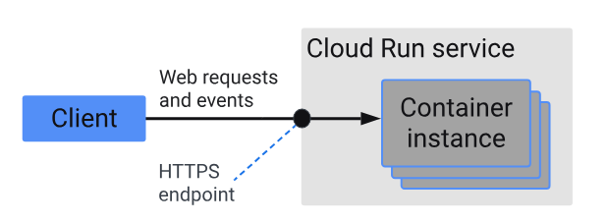

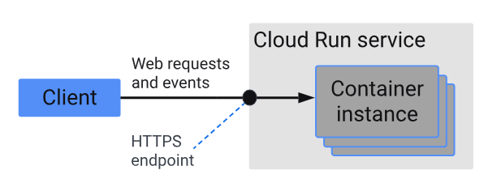



# Create Cloud Run and Deploy Sample container

To deploy a container, follow these steps:

1. In the Google Cloud console, go to the **Cloud Run** page:
2. Click **Create service**.

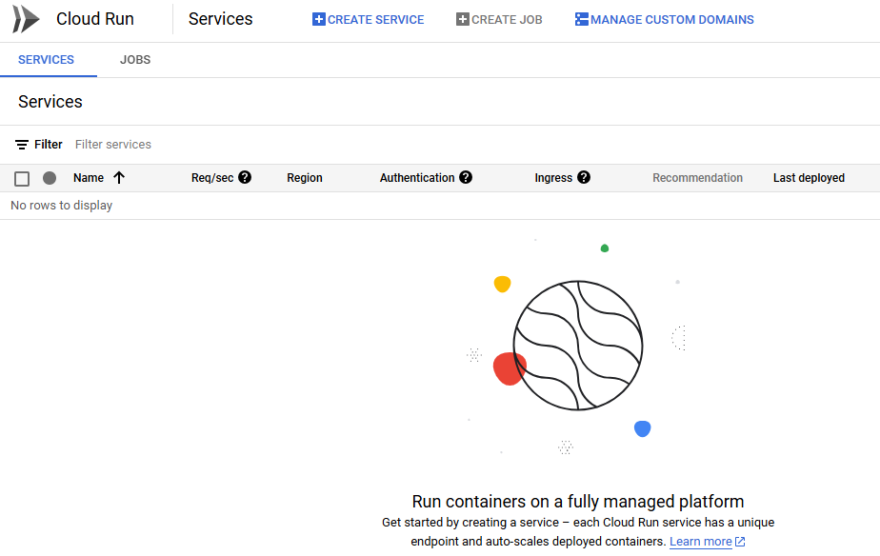

1. Select **Deploy one revision from an existing container image**.
2. For **Container image URL**,  click **Test with a sample container**.
3. In the **Service name** field, enter a service name or use the default value.
4. In the **Region** list, use the default value us-central1
5. In the **Authentication** section, select **Allow unauthenticated invocations**.

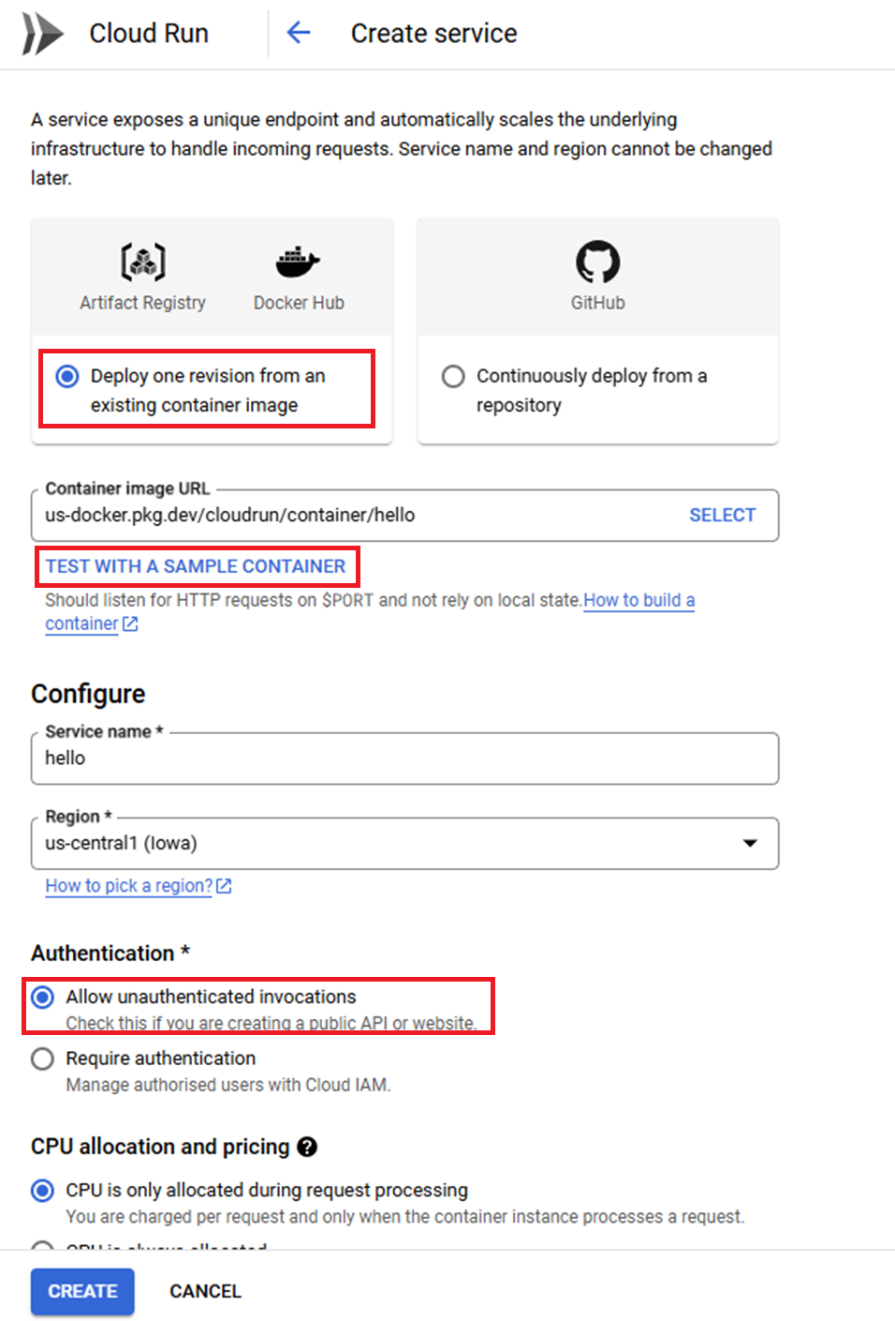

1. In the **Container, Volumes, networking and security** section, change **Port to 80**

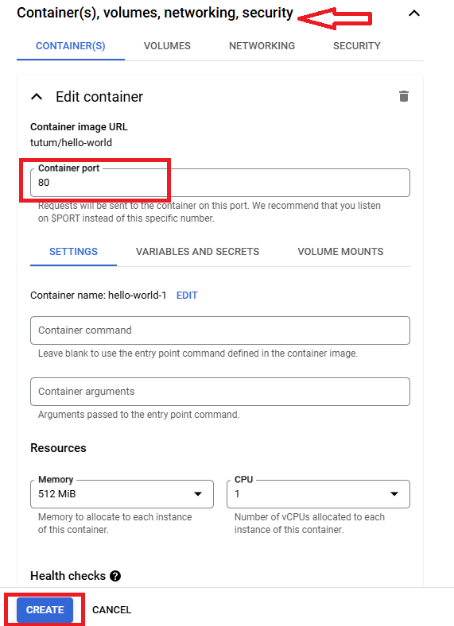

1. Click **Create**, and then wait for the container to deploy to Cloud Run. After deployment, the container's URL is displayed next to the text **URL:**.

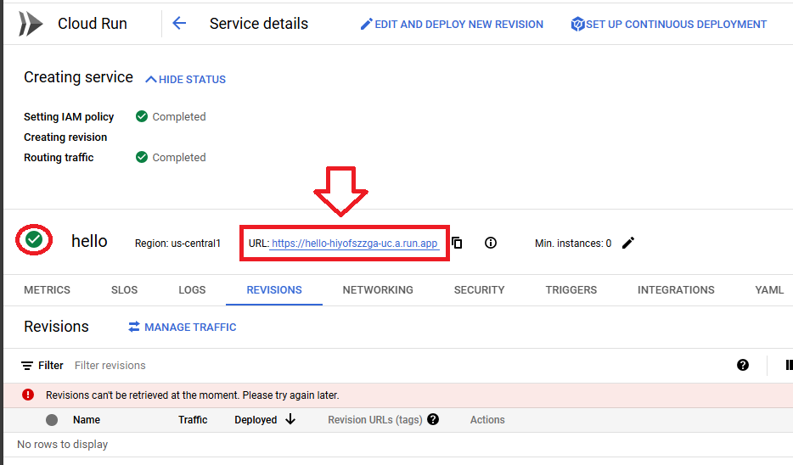

1. To view the running container, click content_copy **Copy to clipboard** to copy its URL, and then paste the URL into your browser's address bar.

